Huawei Technologies Co., Ltd. | Product Name | Confidentiality
Huawei Technologies Co., Ltd. | NetworkOS | Internal
Huawei Technologies Co., Ltd. | Product Version | 33 pages

OPS2.0 Manual

Prepared by | Liu Xuemin | Date | 2013-10-10
Reviewed by |  | Date
Reviewed by |  | Date
Approved by |  | Date


Huawei Technologies Co., Ltd.
All Rights Reserved

About This Document
Change History
Date | Version | CR No. | Chapter | Description | Prepared By
2013-10-10 | 1.00 |  |  | Completed the initial draft. | Liu Xuemin/00138631

Contents
About This Document ii
1 Overview 1
1.1 Software Requirements 1
1.2 Scope 1
1.3 Releasing the Directory Structure 2
2 Installation Wizard 3
2.1 One-Click Installation 3
2.2 Installing and Testing the Client 4
3 Usage Guide 6
3.1 Starting OPS Server 6
3.2 List for Device Management 6
3.2.1 Adding a Device 6
3.2.2 Viewing Devices 7
3.2.3 Updating Device Information 7
3.2.4 Deleting a Device 8
3.3 Subdevice Management 8
3.3.1 Adding a Subdevice 8
3.3.2 Modifying the Subdevice 9
3.3.3 Deleting a Subdevice 9
3.4 IP Address Whitelist Management 10
3.4.1 Adding an IP Address Whitelist 10
3.4.2 Obtaining an IP Address Whitelist 11
3.4.3 Deleting an IP Address Whitelist 12
3.5 User Management 13
3.5.1 Adding a User 13
3.5.2 Obtaining All Users 14
3.5.3 Modifying an Existing User 15
3.5.4 Changing the Password of the Current Account 16
3.5.5 Deleting a User 17
3.6 Role Query 18
3.6.1 Querying a Role 18
3.7 Using RESTful APIs to Manage Information in the Device 18
3.7.1 Obtaining Information from the Device 18
3.7.2 Modifying Information in the Device 20
3.7.3 Adding Information to the Device 20
3.7.4 Deleting Information from the Device 21
3.7.5 Supporting the JSON Format for Returning Data 22
3.7.6 Supporting the JSON Format for Entering Data 23
3.7.7 Supporting ls/vs-based Access 23
3.8 Other NETCONF Capabilities 24
3.8.1 Action 24
3.8.2 Distinct Startup 24
3.8.3 Rollback on Error 26
3.8.4 delete-config 26
3.8.5 kill-session 27

Overview

Software Requirements
Software | Version
Microsoft Windows | Windows XP SP2, Windows Server 2003, and other Windows operating systems
Python | Python 2.7.3
Third-party Python plug-ins | - pycrypto-2.6.tar.gz  - pyasn1-0.1.6-py2.7.egg  - lxml-2.3-py2.7-win32.egg  - xmltodict-0.4.2.tar.gz  - generateDS-2.8a-py2.7.egg  - gevent-0.13.8.win32-py2.7.exe  - greenlet-0.4.0.win32-py2.7.exe  - pysnmp-4.2.4-py2.7.egg  - websocket-client-0.9.0.tar.gz  - gevent-websocket-0.3.6.tar.gz

Scope
VRP OPS2.0 provides RESTful APIs for access to the device. The main functions are as follows:
            - Device management
            - Subdevice management
            - IP address whitelist management
            - User management
            - Role query

Releasing the Directory Structure

Installation Wizard

One-Click Installation
            - Access the URL to download the package and click install.bat for one-click installation.
            - Python 2.7 installation path is C:\Python27. Perform the following operations to add this path to the system environment variables:
Choose Computer > Properties > Advanced system settings > Environment Variables, select Path, and click Edit.
              - Setting the environment variable
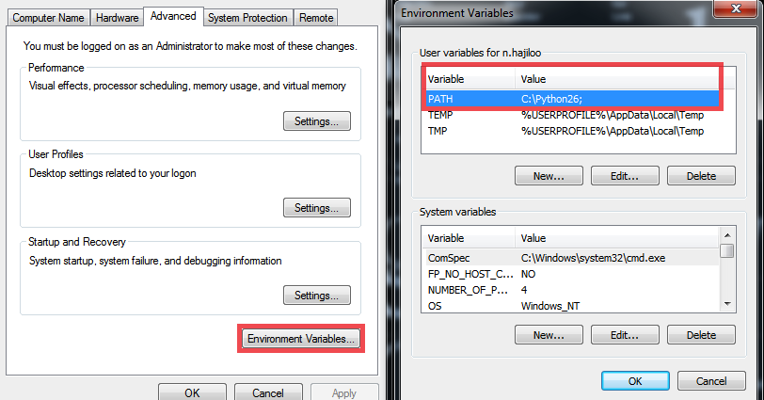

            - Add ;C:\Python27; to the path.
If another Python version has been installed, prioritize the latest version.
            - Start cmd.exe and enter python. If the installation succeeded, the following information is displayed.
              - Using cmd.exe to check the installation
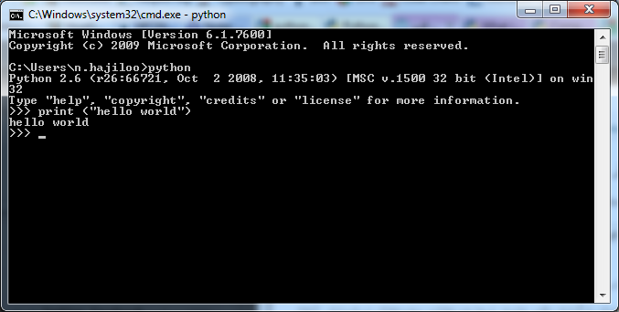

Installing and Testing the Client
Install the Firefox browser and RESTClient plug-in as follows:
            - Run Firefox-full-latest.exe and install the Firefox browser step by step.
            - Install the RESTClient plug-in for Firefox.
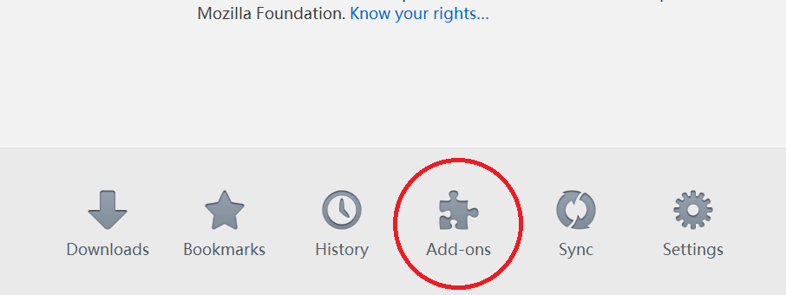

            - Click Add-ons
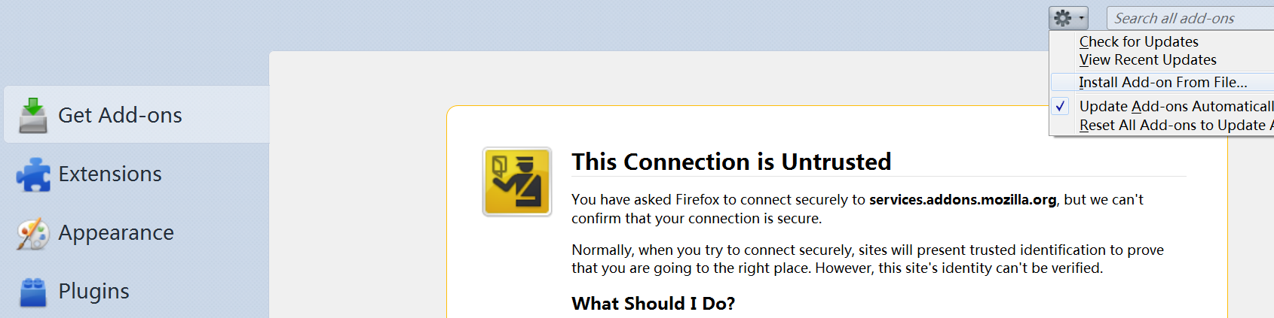

            - Select Install Add-on From File… from the drop-down list and select restclient_a_debugger_for_restful_web_services-2.0.3-fx.xpi.

            - Check whether the installation succeeds as follows:
- Open a new tab in Firefox.
- Click the displayed . If the installation succeeded, the following UI is displayed:
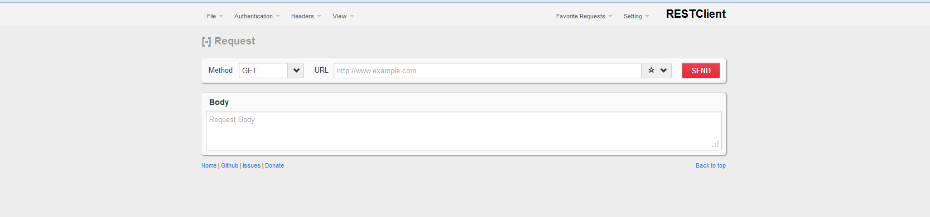

Usage Guide

Starting OPS Server
Install StartOPS.bat in the installation directory and start OPS Server.
Access the URL in the following format:
http://<IpAddress>:<port>
< IpAddress > indicates the OPS Server address.
<port> indicates the listening port. The default OPS Server listening port is 8080.
http://10.135.34.246:8080 is an example of http://<IpAddress>:<port>.
Command Line Help:
python Bottle_WebFrame.py [ -serverip <ipaddr> -port <portnum> ] [ -loglevel <level> ] [ -certfile <certfile> ] [ -auth <true|false> ] [ -whitelist <true|false>] [-channelnum <number>] [-checkesn <true|false>]

Item | Description
-auth <true|false> | To enable a user, add parameter -auth tru to OPS2.0.bat. The raw user name is admin, and raw password is admin.
-whitelist <true|false> | To enable the IP address whitelist, add parameter -whitelist tru to OPS2.0.bat. Before enabling, add the IP address of the local host to the whitelist. Otherwise, the access fails.
-serverip <ipaddr> | This command configures the address of the server bound to the OPS, used in the scenario of multiple network adapters or when a specific address is to be bound.
-port <portnum> | This command configures the service port bound to the OPS. The default port is 8080. The port number can be changed if the address conflicts with the local address.
-loglevel <level> | This command configures the log level. The following log levels are supported: DEBUG, INFO, WARNING, ERROR, and CRITICAL.
-channelnum <number> | This command configures the maximum number of connections for each forwarder.
-certfile <certfile> | To generate an SSL certificate, use the OpenSSL in Linux.  1) You can run the following commands to generate the server.pem certificate: openssl req -new -x509 -keyout server.pem -out server.pem -days 365 -nodes  2) Follow the wizard step by step and fill in the server IP address.  3) To enable the SSL function, download server.pem to the OPS2.0 directory and add parameter -certfile server.pem to OPS2.0.bat.  4) Restart. If the operation succeeds, https://xxxx:8080 is displayed.
-checkesn <true|false> | This command checks whether the target devices that IP addresses of the device and its subdevice or subdevices direct to have the same ESN. If not, the device connection is disabled. until the address is modified, or the subdevice directing to the device with the different ESN is deleted.  PS: An ESN is the unique identification of a device.
OpenSSL : Follow the wizard step by step and fill in the server IP address to enable https:
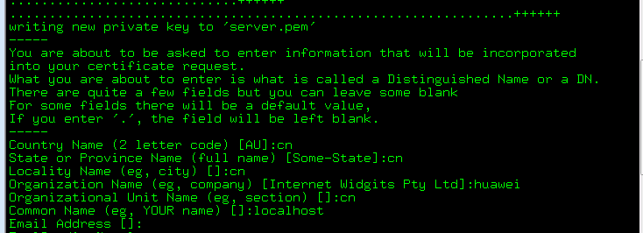

List for Device Management
The OPS Server can manage multiple devices. A user can view, add, update, and delete device information in the client by entering correct values for fields Method, URL, and Body.
The device in the device list has its own ID for management.

Adding a Device
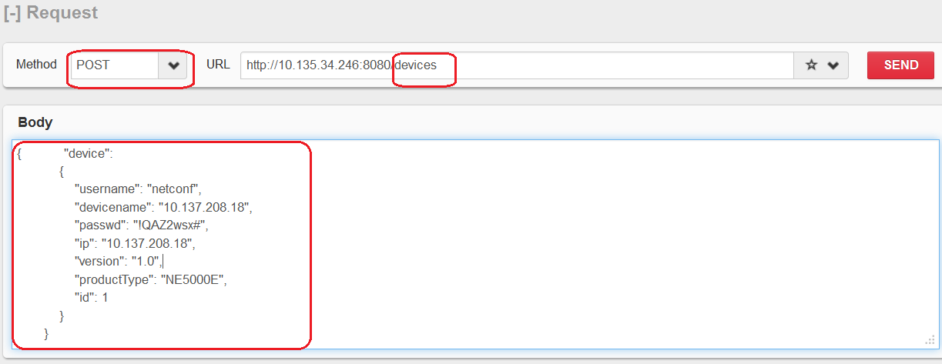

            - After being added, a device ID is generated.
            - Enter the correct device information in Body.

Viewing Devices
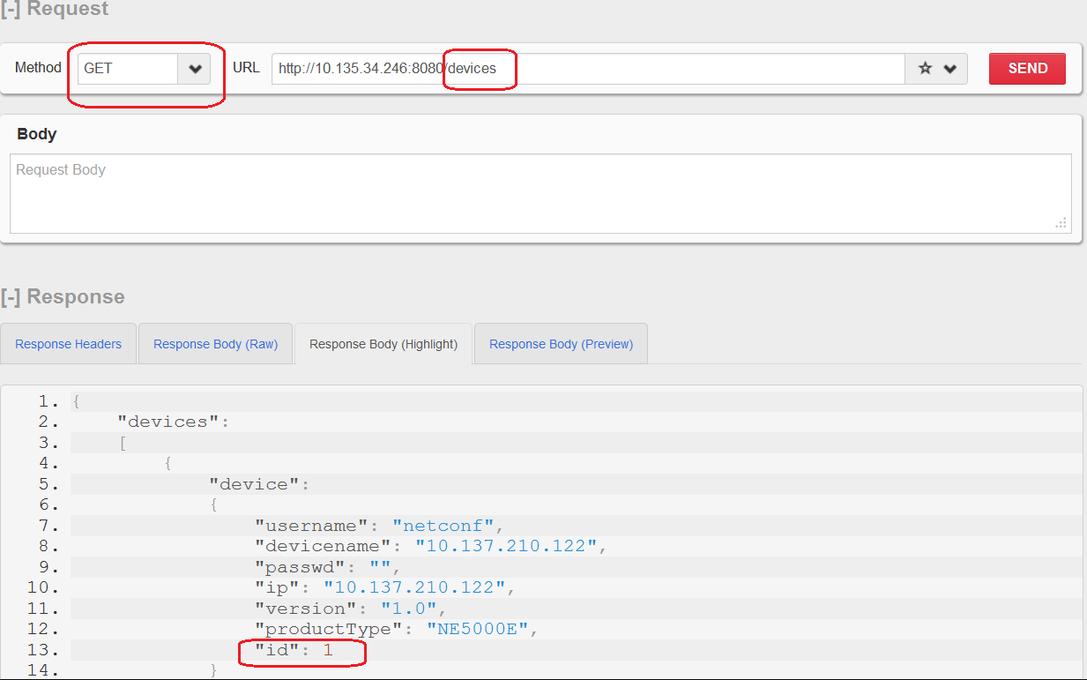

Updating Device Information
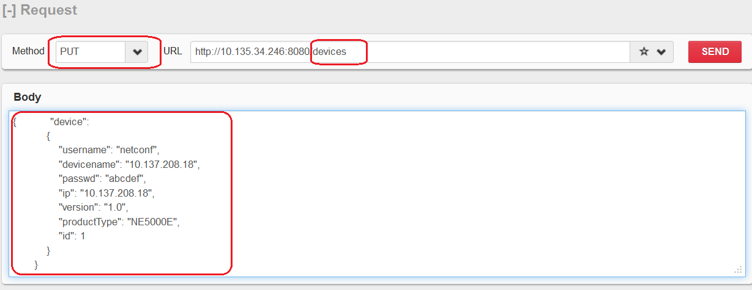

The update is based on device IDs.

Deleting a Device
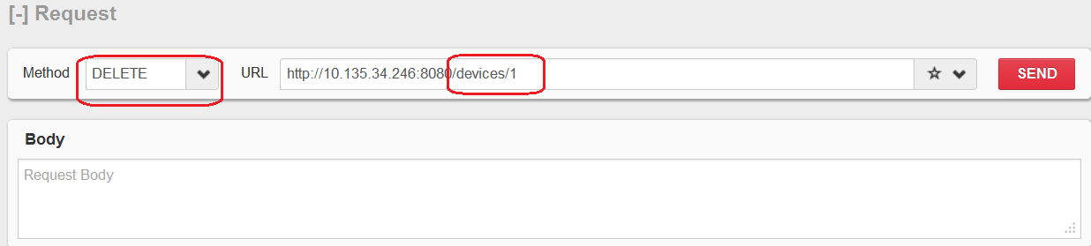

Subdevice Management

Adding a Subdevice
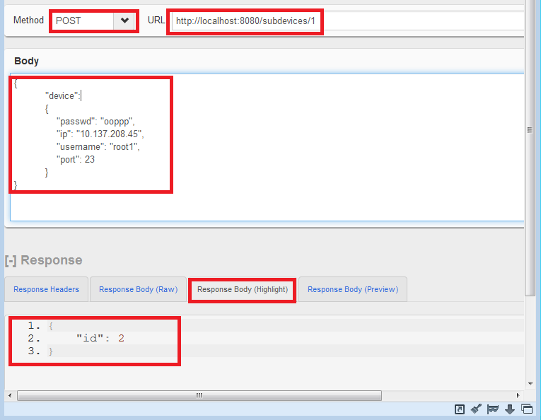

            - After being added, a subdevice ID is generated.
            - Enter the correct subdevice information in Body.

Modifying the Subdevice
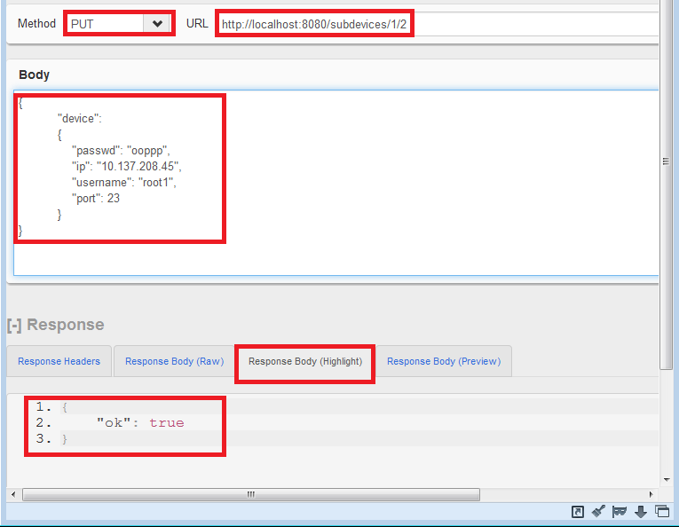

The modification is based on the subdevice ID.

Deleting a Subdevice
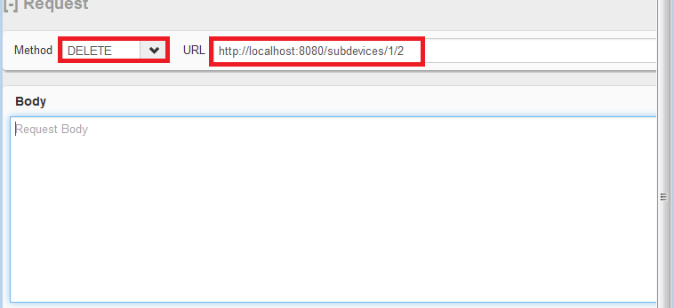

The deletion is based on the subdevice ID.

IP Address Whitelist Management

Adding an IP Address Whitelist
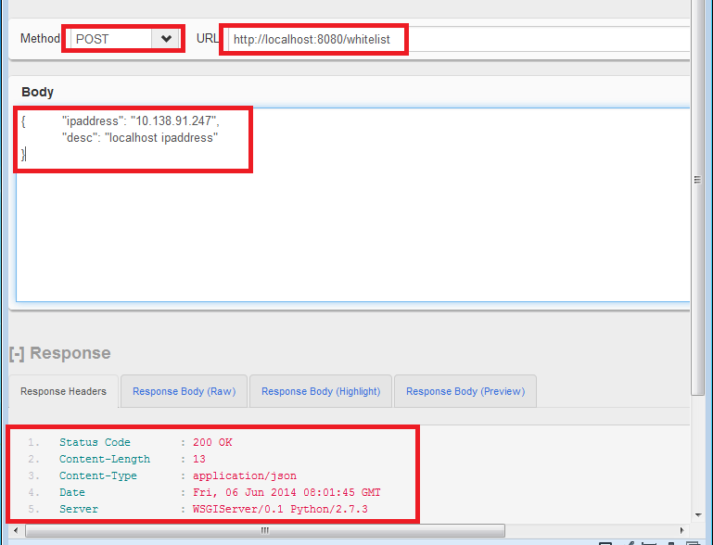

Obtaining an IP Address Whitelist
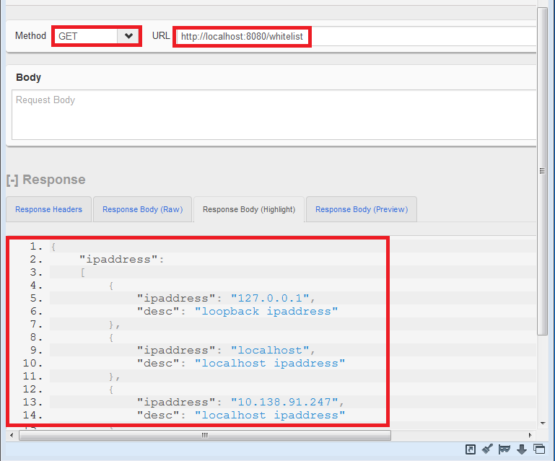

Deleting an IP Address Whitelist
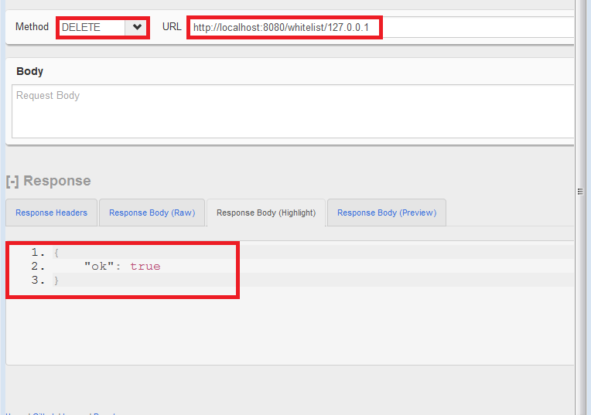

User Management

Adding a User
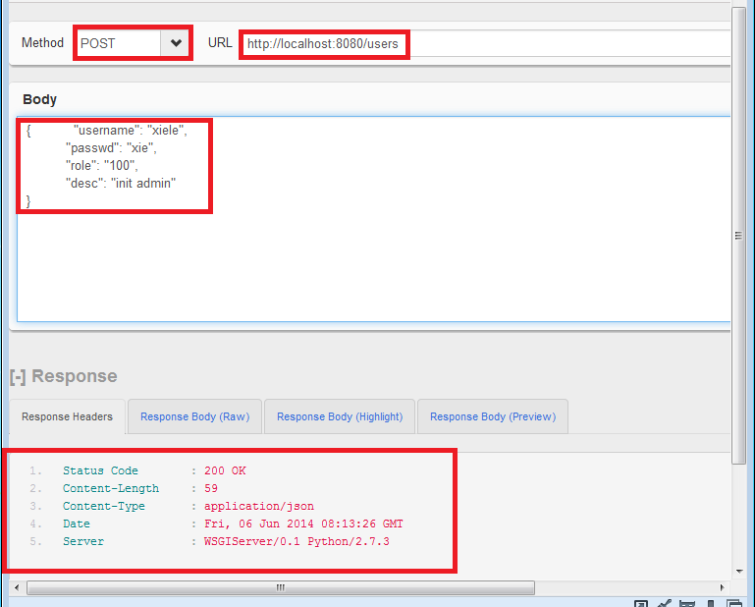

Obtaining All Users
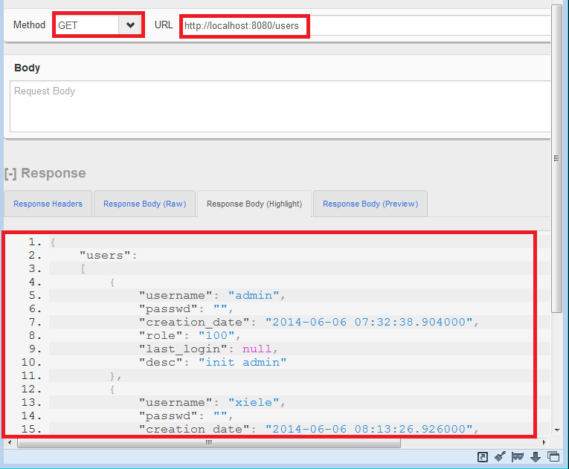

Modifying an Existing User
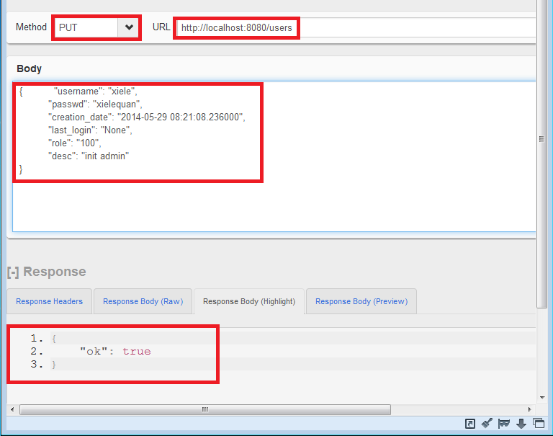

Changing the Password of the Current Account
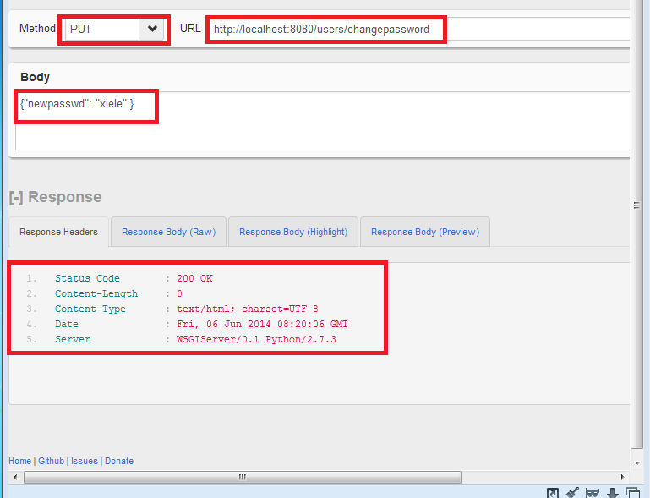

Deleting a User
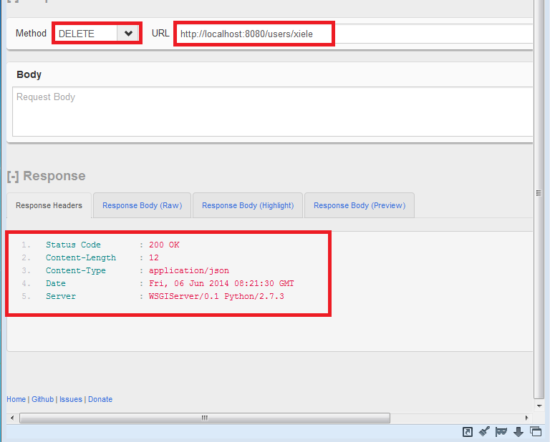

Role Query

Querying a Role
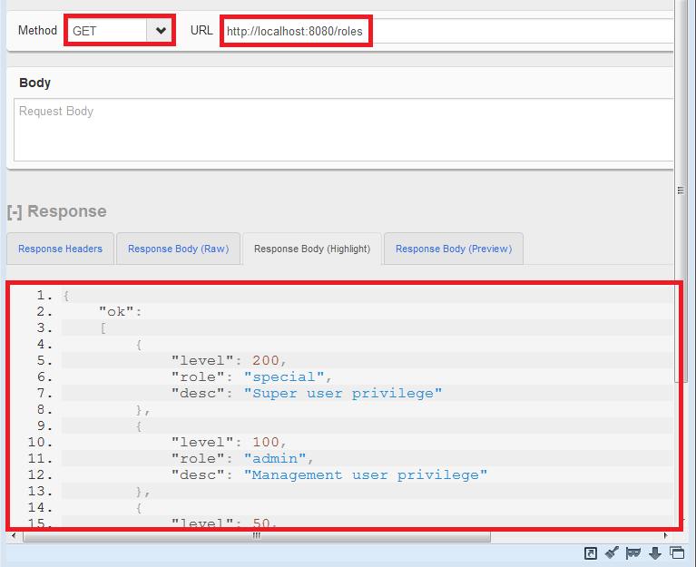

Using RESTful APIs to Manage Information in the Device

Obtaining Information from the Device
This action corresponds to get in NETCONF RPC packets.
The following part is an example.
            - Get the interface information.
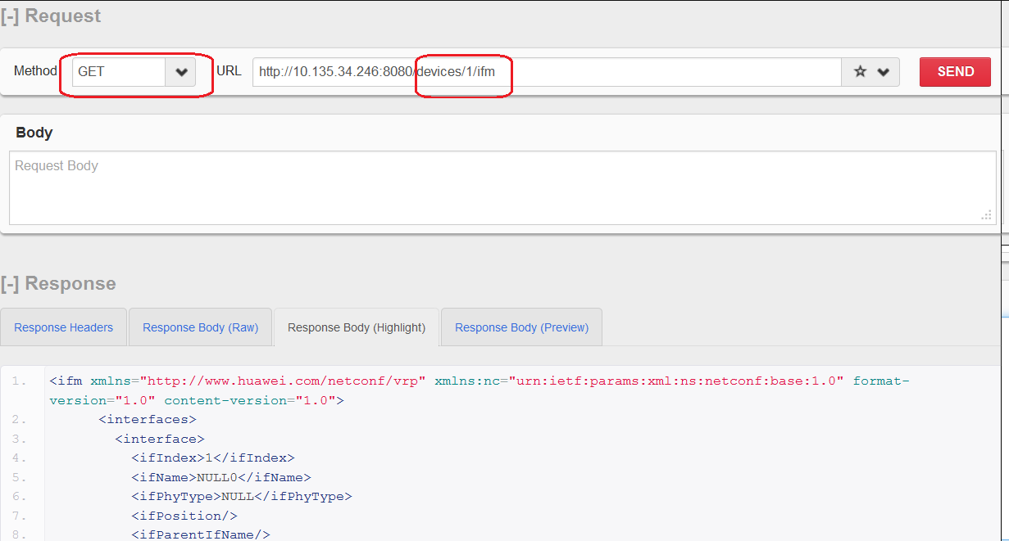

            - View the information of an interface.
In the URL, add ?ifName=Ethernet3%2F0%2F0 to the ending of ifm/interfaces/interface, as shown in the following figure. / is converted to %2F.
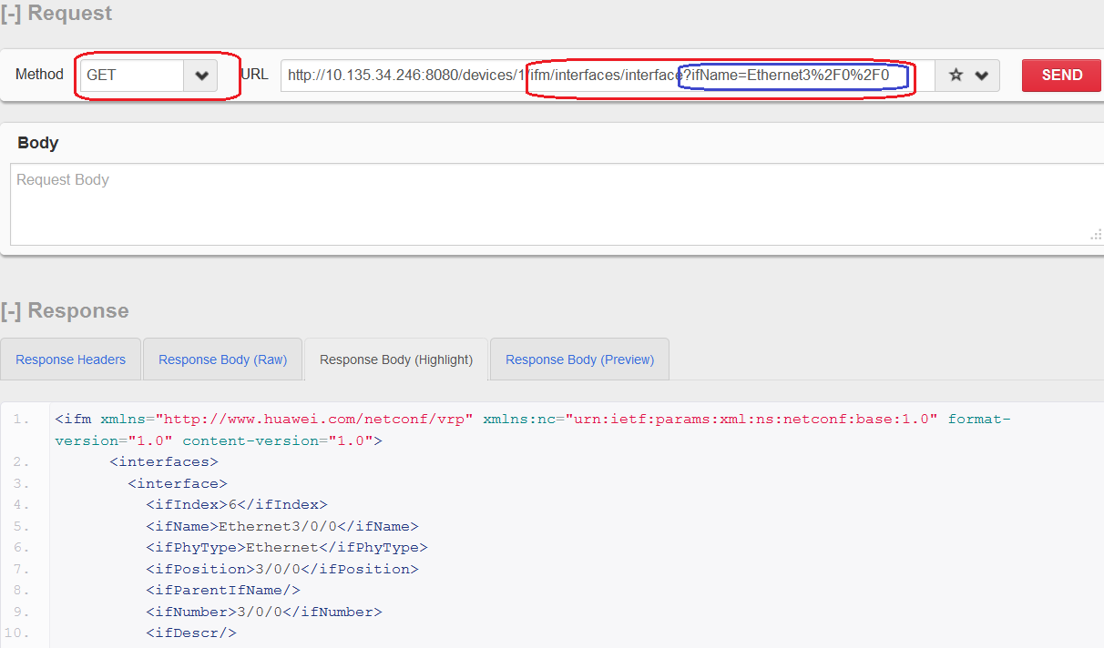

            - View the information displayed in the JSON format.
Add /josn to the end of the URL. The default format is XML.
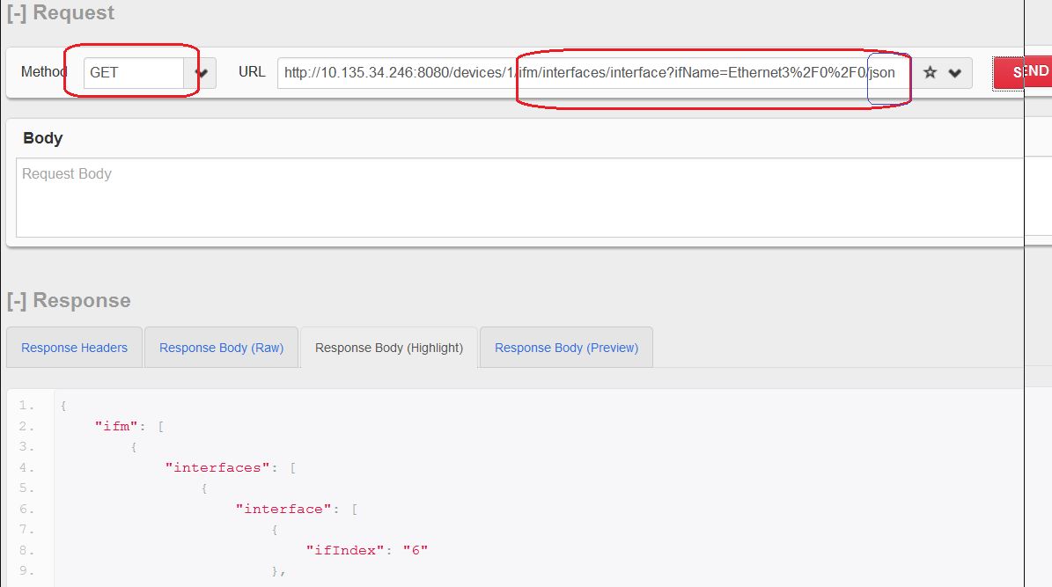

Modifying Information in the Device
This action corresponds to merge in NETCONF RPC packets.
The following part is an example.
            - Set the status of Ethernet3/0/0 to Up.
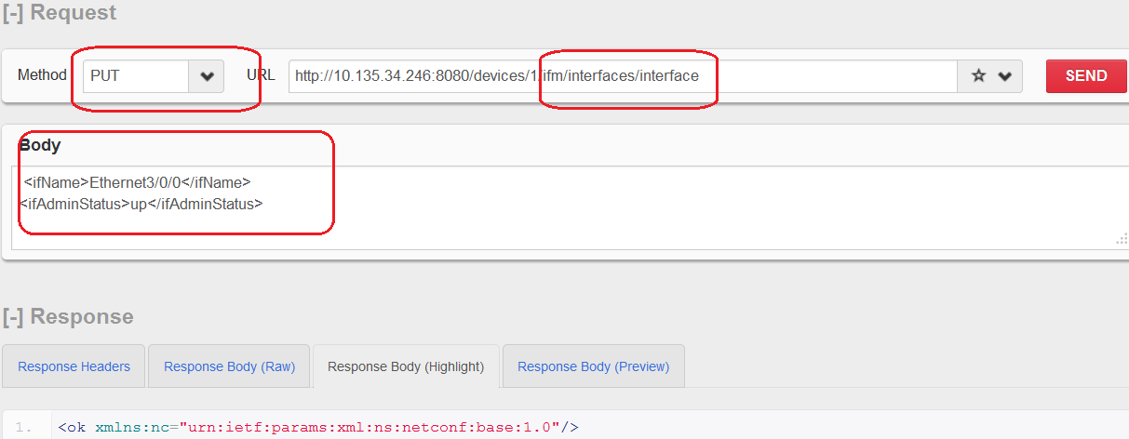

Adding Information to the Device
This action corresponds to create in NETCONF RPC packets.
The following part is an example.
            - Add a VLAN to the device.
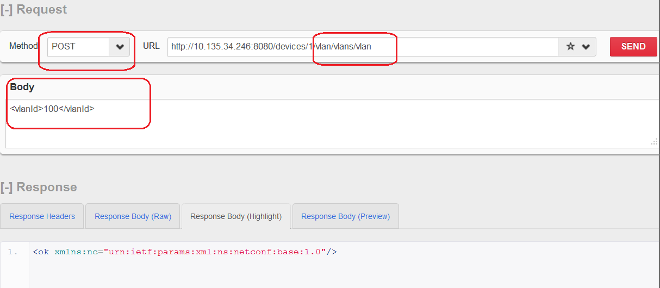
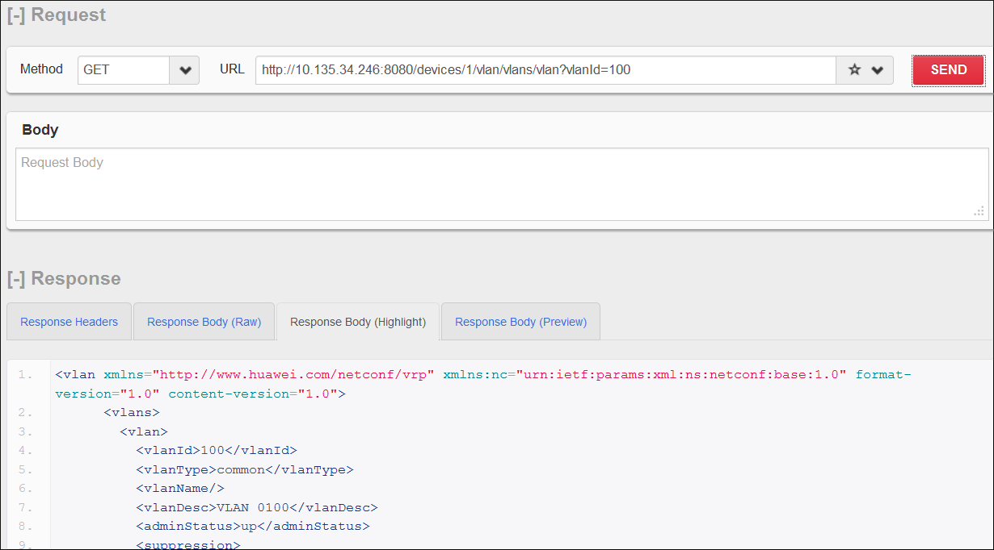

Deleting Information from the Device
This action corresponds to delete in NETCONF RPC packets.
The following part is an example.
            - Delete a VLAN from the device.
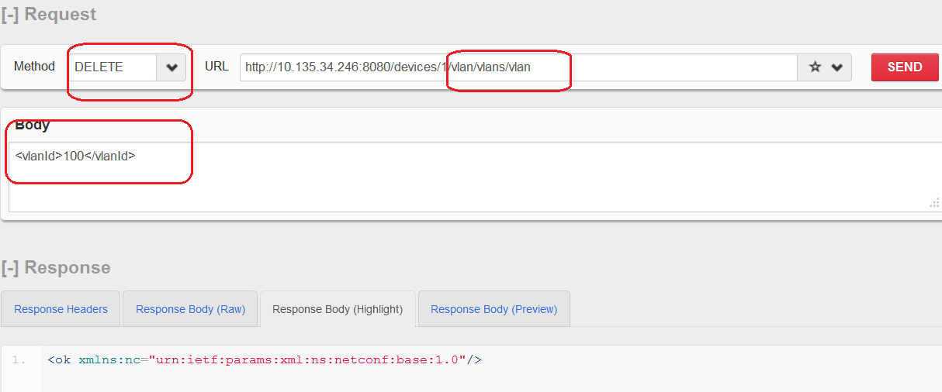

Supporting the JSON Format for Returning Data
The information can be displayed in the JSON format. Add /josn to the end of the URL. The default format is XML.
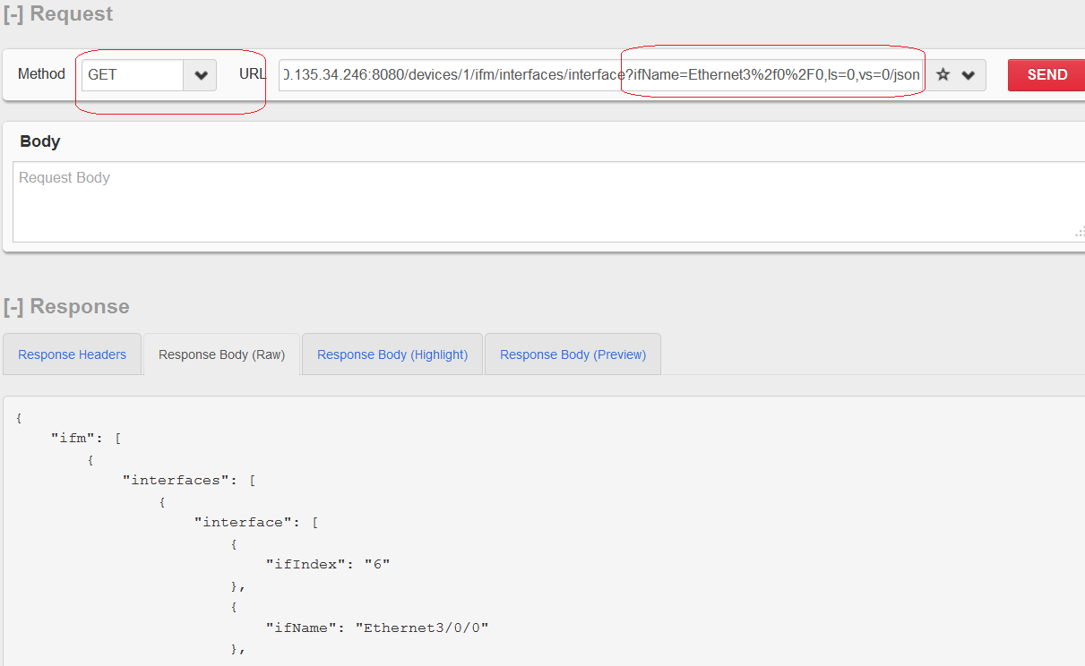

Supporting the JSON Format for Entering Data
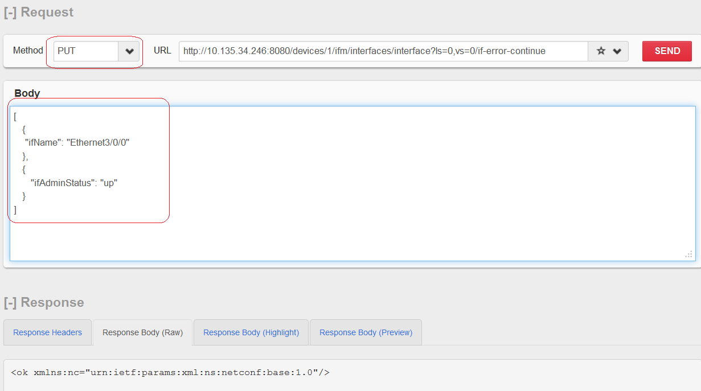

Supporting ls/vs-based Access
Example 1
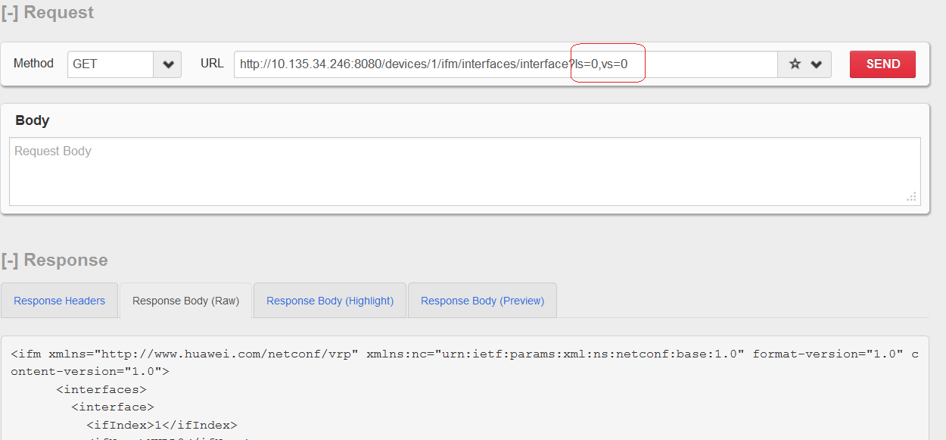

Example 2
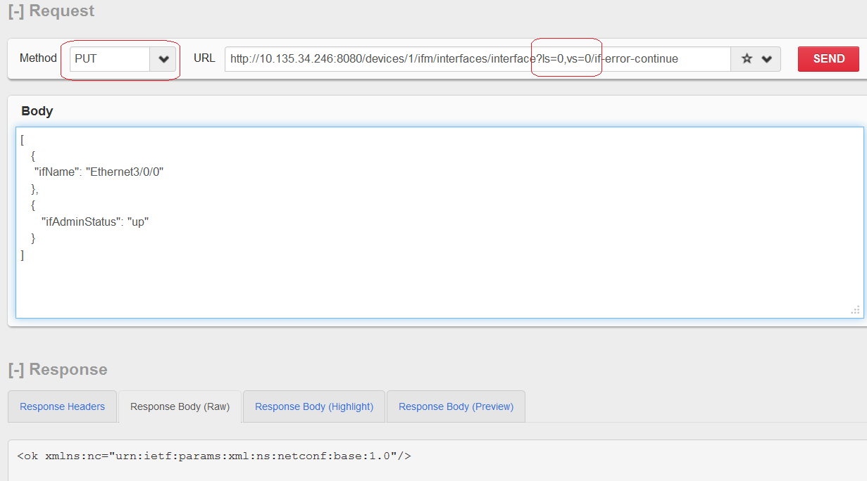

Other NETCONF Capabilities

Action
Operation Action correspond to Post. Add _action to the end of the URL.
For example, the following figure shows how to change the configuration file.
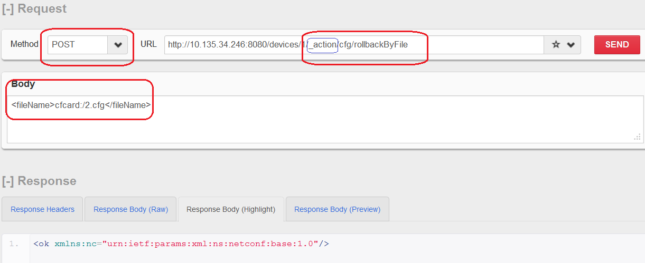

Distinct Startup
Restful API: POST URI : /copy-config/?ls=0,vs=0 or /copy-config?ls=0,vs=0
Enter the following information in Body:
The XML format is as follows:
<target>
<url>huawei.cfg</url>
</target>
<source>
<running/>
</source>

The JSON format is as follows:
[
{ "source":"running"},
{ "target":{
"url":"huawei.cfg"
}
}
]
Or you can enter the following information:
[
{ "source":"running"},
{ "target":"huawei.cfg"}
]
The following part is an example.
Example 1: Save to the configuration file.
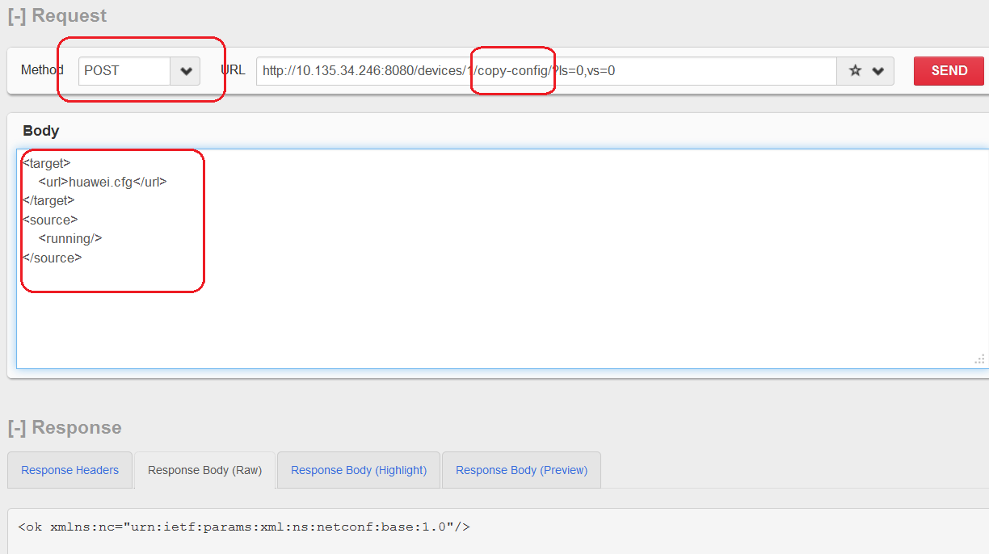

Example 2: Save to the current configurations.
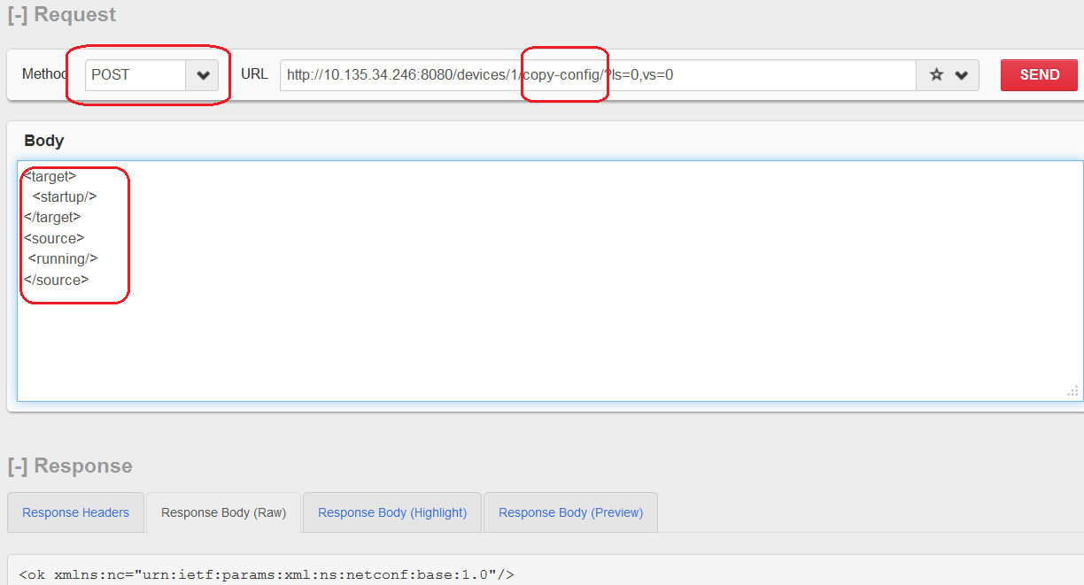

Rollback on Error
Operations POST, PUT, and DELETE support the capability of rollback on error. By default, it stops upon an error.
xpath:
/vlan/vlans/vlan?vlanId=12/if-error-continue
/vlan/vlans/vlan?vlanId=12/ if-error-rollback
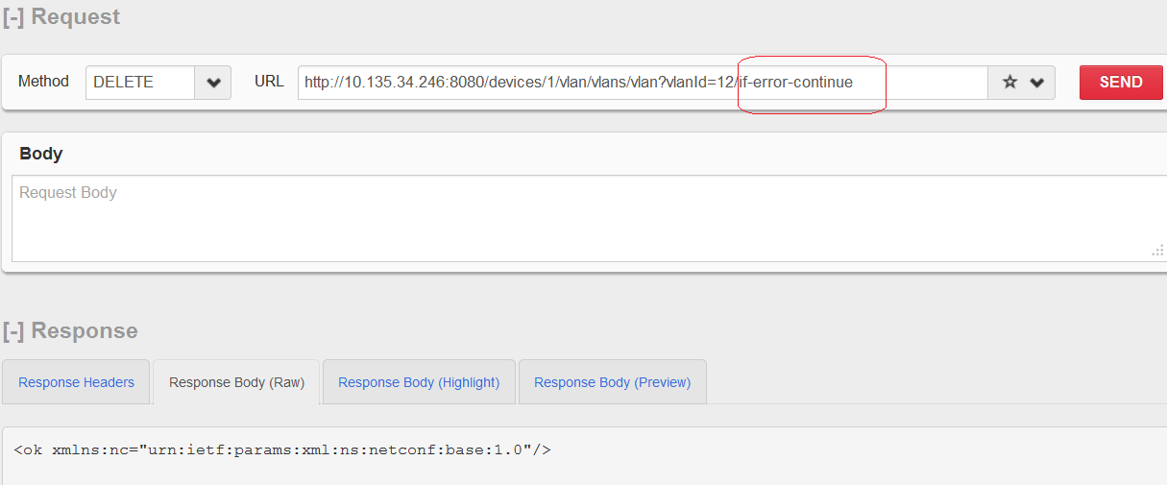

delete-config
Restful API:
POST URI : /delete-config or /delete-config/?ls=0,vs=0
Enter the following information in Body:
The XML format is as follows:
<target>
<url>huawei.cfg</url>
</target>

The JSON format is as follows:
[{ "target": "huawei.cfg"}]
Or you can enter the following information:
[
{ "target":{
"url":"huawei.cfg"
}
}
]
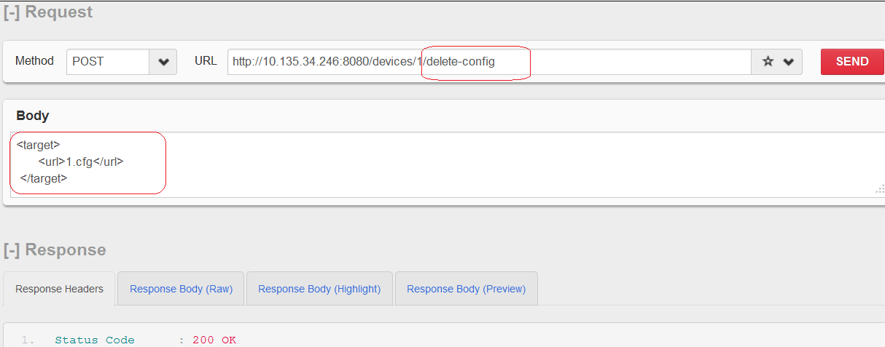

kill-session
Restful API:
POST URI :/kill-session?session-id=100
Or you can enter /kill-session, and enter the session ID in the body.
Enter the following information in Body:
The XML format is as follows:
<session-id>0</session-id>

The JSON format is as follows:
[
{"session-id":"0"}
]

